

**Programming Fundamentals (Lab)**

# Assignment: 01

**Submitted by:** Muhammad Raffey

**Submitted to:** Sir Ahmad Faraz

**Section:** BSCS 2I

**Sap ID:** 70153209

# Q1- Matrix Multiplication

## Code:

**#include <iostream>**

**#include <windows.h>**

**using namespace std;**

**int main()**

**{**

**system("Color FC");**

**int matrix1[2][2], matrix2[2][2], result[2][2];**

**cout << "Enter elements of the first 2x2 matrix:" << endl;**

**for (int i = 0; i < 2; ++i)**

**{**

**for (int j = 0; j < 2; ++j)**

**{**

**cin >> matrix1[i][j];**

**}**

**}**

**cout << "Enter elements of the second 2x2 matrix:" << endl;**

**for (int i = 0; i < 2; ++i)**

**{**

**for (int j = 0; j < 2; ++j)**

**{**

**cin >> matrix2[i][j];**

**}**

**}**

**for (int i = 0; i < 2; ++i)**

**{**

**for (int j = 0; j < 2; ++j)**

**{**

**result[i][j] = 0;**

**}**

**}**

**for (int i = 0; i < 2; ++i)**

**{**

**for (int j = 0; j < 2; ++j)**

**{**

**for (int k = 0; k < 2; ++k)**

**{**

**result[i][j] += matrix1[i][k] * matrix2[k][j];**

**}**

**}**

**}**

**cout << "The resulting matrix is:" << endl;**

**for (int i = 0; i < 2; ++i)**

**{**

**for (int j = 0; j < 2; ++j)**

**{**

**cout << result[i][j] << " ";**

**}**

**cout << endl;**

**}**

**return 0;**

**}**

## Output:

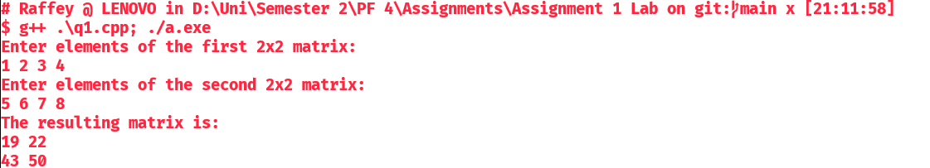

# Q2- Library Management System

## Code:

**#include <iostream>**

**#include <string>**

**#include <windows.h>**

**using namespace std;**

**int main()**

**{**

**system("Color FC");**

**const int racks = 5;**

**const int shelves = 4;**

**string libraryRack[racks][shelves];**

**for (int i = 0; i < racks; i++)**

**{**

**for (int j = 0; j < shelves; j++)**

**{**

**libraryRack[i][j] = "Empty";**

**}**

**}**

**char choice;**

**do**

**{**

**cout << "\nCurrent Library Rack Contents:\n";**

**for (int i = 0; i < racks; i++)**

**{**

**for (int j = 0; j < shelves; j++)**

**{**

**if (libraryRack[i][j] != "Empty")**

**{**

**cout << "Rack " << i + 1 << ", Shelf " << j + 1 << ": " << libraryRack[i][j] << endl;**

**}**

**}**

**}**

**cout << "\nDo you want to place a book in the library? (y/n): ";**

**cin >> choice;**

**if (choice == 'y' || choice == 'Y')**

**{**

**int rackNumber, shelfNumber;**

**string bookTitle;**

**cout << "Enter the rack number (1-5): ";**

**cin >> rackNumber;**

**cout << "Enter the shelf number (1-4): ";**

**cin >> shelfNumber;**

**cout << "Enter the title of the book: ";**

**cin >> bookTitle;**

**if (rackNumber >= 1 && rackNumber <= racks && shelfNumber >= 1 && shelfNumber <= shelves)**

**{**

**libraryRack[rackNumber - 1][shelfNumber - 1] = bookTitle;**

**}**

**else**

**{**

**cout << "Invalid rack or shelf number. Please try again.\n";**

**}**

**}**

**} while (choice == 'y' || choice == 'Y');**

**cout << "\nFinal Library Rack Contents:\n";**

**for (int i = 0; i < racks; i++)**

**{**

**for (int j = 0; j < shelves; j++)**

**{**

**if (libraryRack[i][j] != "Empty")**

**{**

**cout << "Rack " << i + 1 << ", Shelf " << j + 1 << ": " << libraryRack[i][j] << endl;**

**}**

**}**

**}**

**string searchTitle;**

**cout << "\nEnter the title of the book you want to find: ";**

**cin >> searchTitle;**

**bool found = false;**

**for (int i = 0; i < racks; i++)**

**{**

**for (int j = 0; j < shelves; j++)**

**{**

**if (libraryRack[i][j] == searchTitle)**

**{**

**cout << "Book '" << searchTitle << "' found at Rack " << i + 1 << ", Shelf " << j + 1 << endl;**

**found = true;**

**break;**

**}**

**}**

**if (found)**

**break;**

**}**

**if (!found)**

**{**

**cout << "Book '" << searchTitle << "' not found in the library.\n";**

**}**

**cout << "\n-----------------------------\nThank You for Using Raffey's Library\n-----------------------------\n";**

**return 0;**

**}**

## Output:

